Max Krause

Kreause electric cars  3 Cherrywood Cres Llanarth

Krause Electric Cars Detailed design report

# Contents:

Contents: 1

Concept Map 7

User-friendly Navigation and Interface: 7

Content Clarity: 7

Professional Design Reflective of Brand: 7

Validation of HTML and CSS Files: 7

Folder Structure for File Organization: 7

Index – Main Page 8

About: 8

Resume 8

Web Skills 8

Products 8

Car1 8

Car2 8

Gallery 8

CSS Design: 9

Navigation Map & Structure Chart 15

Story Boards 16

Index – Main Page 16

16

About: 17

Resume 18

Web Skills 19

Products 20

Car1 21

Car2 22

Gallery 23

Testing Plan: 25

Functional Testing: 25

Compatibility Testing: 25

Performance Testing: 25

Performance Testing: 25

Code consistency and quality testing. 25

Index.html 25

Web Skills.html 28

28

Products.html 29

Falcon.html 30

Skyline.html 31

Gallery.html 32

Style.CSS 33

New Additions 34

Hosting 34

Newsletter JavaScript 34

Skills 38

Professional skill & Experience 39

Networking Skills 40

Mechanical Skills 41

Web Skills 42

43

Photography skills 44

New Design implementation diagram 45

Code consistency and quality testing. 46

Skill1.html 46

Skill2.html 47

Skill3.html 49

Skill4.html 51

Skill5.html 54

**The rest of this page is intentionally left blank.**

# Concept Map

In order to ensure an efficient and user-friendly interface, a number of design elements must be carefully considered when creating a website for Krause electric cars. The basic qualities required to create a website of that kind are described in this report, with an emphasis on technical integrity, visual appeal, content clarity, and usability. In order to make sure that the marker can see the styling, I have chosen to use a wide range of conflicting colours for this assignment.

### User-friendly Navigation and Interface:

For any website to be useable by people and kept in and of a manner that allows for this navigation and interface must be taken into account at the design stage to ensure this requirement is met.

Users should be directed to the various sections of the website that are of greater importance with clear and concise use of the tools web developers have at their disposal.

### Content Clarity:

The information on the website should be clear, concise, and educational, giving users all the knowledge they need to understand Krause Electric Cars. This comprises:

Concise Descriptions: Product, service, and company information should be described succinctly to avoid confusing visitors with too much information.

Visual Aids: By including pertinent photos and videos, you can visually engage visitors and highlight important points, which will improve their comprehension of Krause Electric Cars, such as a logo image.

### Professional Design Reflective of Brand:

The website should have a professional feel to it and should represent the brand identity of Krause Electric Cars.

Components of Branding: The website's use of the Krause electric cars logo, colour scheme, and typography upholds brand recognition and brand consistency.

Clean Design: A design style that is simple and uncluttered helps to project professionalism and keeps visitors from becoming sidetracked or confused.

### Validation of HTML and CSS Files:

Ensuring the validity of external CSS files and HTML is essential. To find and correct any mistakes or inconsistencies, validation will be carried out using W3C Markup Validation Service and the W3C CSS Validation Service fro both my HTML code and CSS.

### Folder Structure for File Organization:

Maintainability and accessibility are improved by arranging graphics, text, HTML files, and other resources in a sensible folder structure.

Best practices consist of:

Different Folders: For the use case of keeping related and unrelated content easily accessible and organised as well as differentiated, I will create distinct folders for images, documents, CSS files, and HTML files aswell as any other assets I may use.

Descriptive Naming: To ensure clarity and ease navigation, give folders and files descriptive names pertinent to their expected content this way they are easily identifiable in future.

For a more detailed and professional feel for the website and more overall applicable content I have opted to add extra pages for more informed navigation my initial concept is as follows:

### Index – Main Page

This will act as the landing page for the website displaying majority of the navigation In the body aswell as other key navigation requirements in the to be designed header.

### About:

An expanded about page containing neater, better formatted text, I am planning to use a fixed container width in order to achieve this.

### Resume

For this variant of the website rather than using href for my resume and my feedback form I plan to integrate a PDF embedded into the browser to which it can be viewed and downloaded.

### Web Skills

The web skills page will be mainly unchanged with minor styling fixes added to brin git upto speed with the new website theme.

### Products

The products page will contain information regarding the services Krause electric cars offers in regards to vehicular restoration, I may transition this into a portfolio page in

### Car1

An example of the work that the company has been able to produce with a detailed breakdown of what has been done to keep styling up to date.

### Car2

An example of the work that the company has been able to produce with a detailed breakdown of what has been done to keep styling up to date.

### Gallery

A large page that has will contain all of the images used across the page with descriptive captions and alt text.

# CSS Design:

The header section is comprised of two sections “header’ which has the following CSS

header {

background-color: #241E20;

color: #fff;

padding: 10px ;

display:flex;

justify-content: space-between;

align-items: center;

} and “.container_head”.

.container_head {

background-color: #241E20;

padding: 20px;

}

Using “header” to organise my buttons and “.container_head” to contain and format my banner image.

The body section makes use of a CSS Element

.container_body {

background-color: #D3D3D3;

padding: 20px;

This allows me to place one large container as my body section with a nice off white colour and 20px padding all round within this I can include extra sections such as the section just prior to the footer.

.container {

max-width: 1200px;

margin: 0 auto;

padding: 20px;

box-sizing: border-box;

color: #fff;

}

.portfolio {

display: grid;

grid-template-columns: repeat(auto-fit, minmax(250px, 1fr));

gap: 20px;

}

.portfolio-item {

background-color: #black;

box-shadow: 0 2px 4px rgba(0, 0, 0, 0.1);

border-radius: 8px;

overflow: hidden;

transition: transform 0.3s ease;

}

.portfolio-item:hover {

transform: translateY(-5px);

}

.portfolio-item img {

width: 100%;

height: auto;

display: block;

}

.portfolio-item-content {

padding: 20px;

}

.portfolio-item-title {

font-size: 1.2rem;

margin-bottom: 10px;

color: black;

}

.portfolio-item-description {

font-size: 0.9rem;

color: #241E20;

}

This section used these CSS rules to format and create nice buttons that include images or videos for nice navigation of the website.

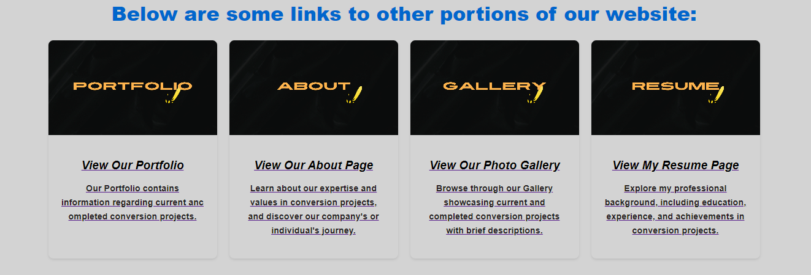

My Footer contains basic styling elements such as a background colour, padding and text alignment.

footer {

background-color: #241E20;

color: #fff;

padding: 10px 0;

justify-content: space-between;

text-align: center;

}



# Navigation Map & Structure Chart

The Navigation Map & Structure Chart are too large to be included in this document so please access them in the documents folder or below in the attached .zip.



The Navigation Structure begins on the home page (Index.html) and lays out the main clickable features on the home page that lead to other areas of the webpage via means of navigation, the home page will consist of buttons within the header that will take the user to the main pages of the website, This will include Home, Resume, Web Skills, About and Gallery. I have included extra containers in the body as supplementary navigation method to this I will include secondary navigation items which include images within containers with brief descriptions about the page to better represent the page the customer is about to navigate to.

Navigation continues from index to Resume; on this page the customer is greeted with the same header design as well as a pdf viewer embed of my resume this will allow them to download it as well as view and scroll between pages of my resume as any browser pdf viewer would handle it. Following this If the user scrolls down they will be greeted with a table including my subject and results – for the purposes of this I have only included ITC 293 as my account is on hold and I cannot access my results. Following this scrolling further down will reveal an embedded form the user can sue to leave feedback on the resume.

Following on from resume we continue to the about page the user will be greeted with the same header and banner design shortly below this will be a short blurb about Krause Electric Cars and their industry statement as well as the content from assessment 2 this will be neatly formatted into a container to keep the paragraph to a fixed page width. The same styling will apply to the assessment 2 content.

Completing navigation from the about page leaves the user with one more menu item to click, that being the gallery item, the gallery page will use containers formatted as gallery items each displaying the images that are being used across the website in a neat 3 wide format scrolling until there are no more images to display, each container will have a caption section which will have a description in place to describe the contents of the image to the user.

Extras:

Extra navigation points come in the form of footer containers at the bottom of some of the main pages these will use looped videos to create an eye catching effect. This will be mainly used to gather attention to the Portfolio page for the business allowing the business to show off their conversion projects and explain their worksmanship.

# Story Boards

### Index – Main Page

### 

This will act as the landing page for the website displaying majority of the navigation In the body as well as other key navigation requirements in the to be designed header.

Body content for this page will mostly consist of information about what the brand can achieve and what they strive to do.

On each major page I would like to implement videos displayed within containers that draw in the users eye encouraging navigation to other areas of the website.

### About:

### Resume

### Web Skills

### Products

### Car1

### Car2

### Gallery

# Testing Plan:

## Functional Testing:

Test all links to ensure they navigate to the correct pages.

Verify forms (Feedback Form) for proper submission and validation.

Check interactive elements such as buttons, hyperlinks, and images for functionality.

## Compatibility Testing:

Test the website on different browsers (Chrome, Firefox, Safari, Edge) to ensure compatibility.

Test on different devices to ensure responsiveness.

Verify compatibility with different operating systems (Windows, MacOS).

## Performance Testing:

Test website loading times.

Check for any slow-loading elements or pages.

## Performance Testing:

HTML & CSS Validation.

# Code consistency and quality testing.

Index.html

About.html

Resume.html

Web Skills.html

## **N**ew Additions

New additions are as follows:

### Hosting

The website is now hosted on the following link using GitHub libraries: <https://yherhr.github.io/ITC293/>

### Newsletter JavaScript

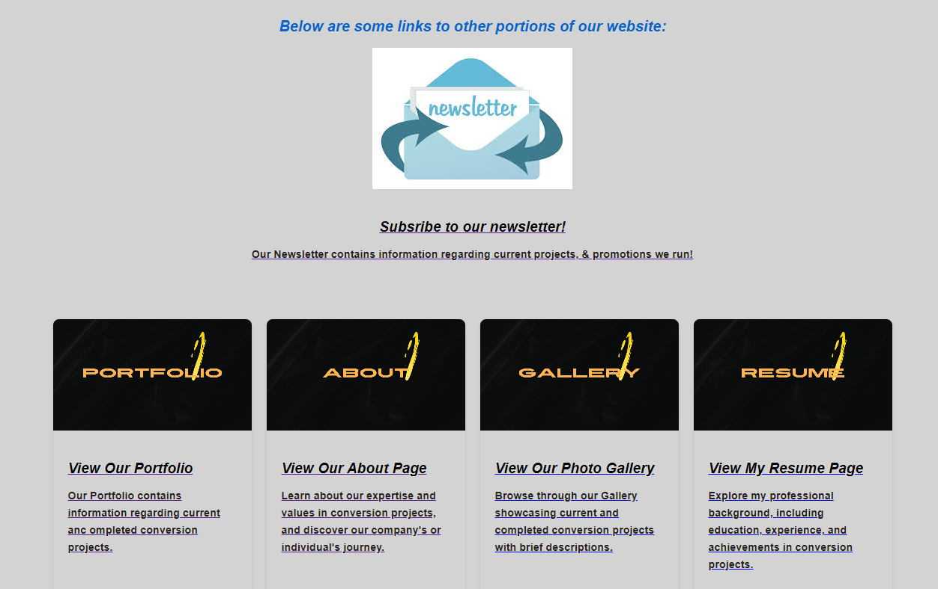

On the bottom of pages, I have added a section within the existing explore section to allow user to sign up to the newsletter for the company.

On clicking this the user will be greeted with the following form in a new tab with the attached announcement.

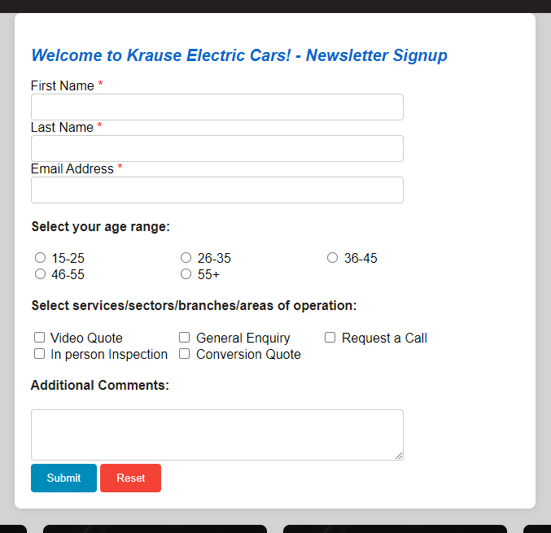

The styling for the newsletter page consists of:

label {

display: inline-block;

width: 150px;

}

input[type="text"],

input[type="email"],

textarea {

width: calc(100% - 160px);

padding: 8px;

border: 1px solid #ccc;

border-radius: 4px;

}

span.required {

color: red;

}

button {

padding: 10px 20px;

background-color: #4CAF50;

color: white;

border: none;

border-radius: 4px;

cursor: pointer;

}

button[type="submit"] {

background-color: #008CBA;

}

button[type="reset"] {

background-color: #f44336;

}

button:hover {

background-color: #0066cc;

}

button[type="reset"]:hover {

background-color: #cc0000;

}

I decided on making the reset button red and the submit button a neutral blue that on hover turns to the website theme of #0066cc.

The script itself consisted of 14 lines of JavaScript as follows:

function validateForm() {

var firstName = document.getElementById("firstName").value;

var lastName = document.getElementById("lastName").value;

if (firstName === "" || lastName === "") {

alert("Both first name and last name are required.");

return false;

}

return true;

}

window.onload = function() {

alert("Welcome to Krause Electric Cars! - Newsletter Signup");

};

The first 3 lines define the validation structure of the form with the first and last name values being declared.

The if statement uses the previous declaration to check that the first name and last name fields contain information before returning a true result.

The last function creates the alert for the website that appears on opening the page and displays the message “Welcome to Krause Electric Cars! - Newsletter Signup” .

## Skills

New body section for skills page to allow for navigation to the new pages created.

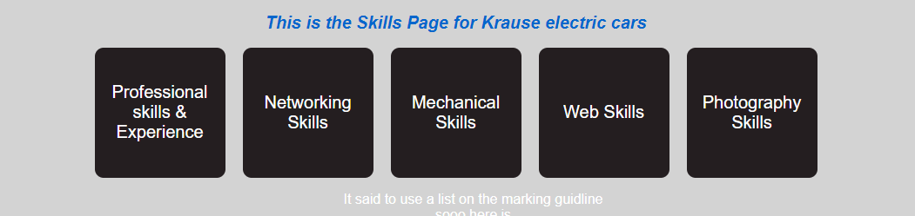

The colour for the buttons matches the header and footer colours (#241E20) with the hover over aspect matched to the accent blue colour(#0066cc).

The CSS for the section is as follows:

.container_box {

display: grid;

grid-template-columns: repeat(2, 150px);

grid-gap: 20px;

display: flex;

justify-content: center;

align-items: center;

}

.box {

width: 150px;

height: 150px;

display: flex;

justify-content: center;

align-items: center;

background-color: #241E20;

color: white;

text-decoration: none;

font-size: 20px;

border-radius: 10px;

transition: background-color 0.3s;

}

.box:hover {

background-color: #0066cc;

}

Each of the buttons in this section navigates the user to a new page designed to showcase the desired skill.

### Professional skill & Experience

This page shares the base theme CSS and includes a PDF embed of my linked in profile as evidence of my professional experience.

### Networking Skills

The Networking skills page takes a paragraph to explain the portions of an assessment I completed regarding network design and implementation and also includes a PDF embed of one of my reports designing a network for a fictitious company “ABC Limited”.

The themes base CSS is still being used to display all op the information on the page with the main aspect of the page sitting in a body container to ensure the text is of a reasonable width.

### Mechanical Skills

By using the existing gallery elements, I created and sitting it inside a body container I was able to get this neat effect with the width of the text and my media lining up well. I modified the html elements to allow for video to be used as well as images and implemented controls and audio so the user can mut play and pause certain aspects.

### Web Skills

For the Web Skills page I used a new image section to neatly display an image and a brief description that is hyperlinked to the project itself:

<div class="image-section">

<a href="External site " target="_blank">

<img src="External CDN " alt="Website 1">

</a>

<div class="description">

<p>Description</p>

</div>

</div>

Upon clicking the image or video the user is taken to my project via a new tab opening up.

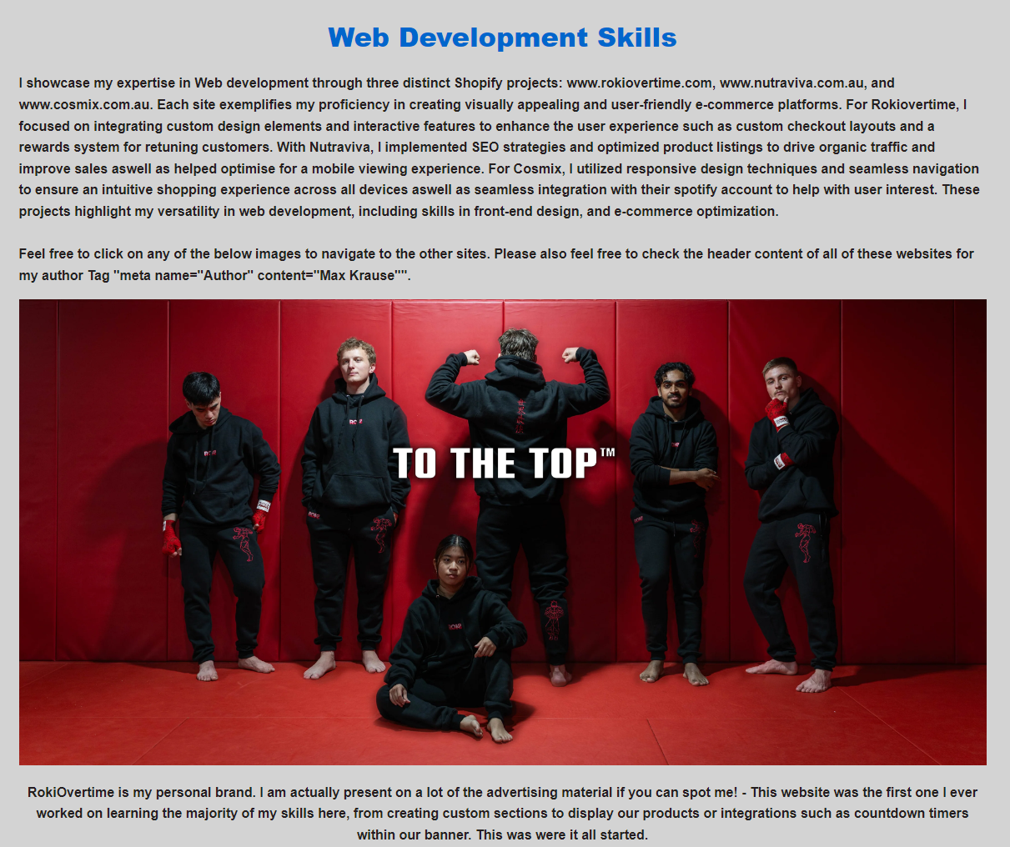

### Photography skills

Photography skills uses the existing gallery section as well as paragraphs to highlight to professional importance of the photography skill as well as giving the user a nice viewing experience that allows them to take a step into the eye of the photographer.

### A close-up of a white background Description automatically generatedNew Design implementation diagram

### Code consistency and quality testing.

### Skill1.html

<body>

<header>

<div class="logo">

<img src="Images/logo.png" alt="Logo">

</div>

<h3>

Krause Electric Cars

</h3>

<nav>

<ul>

<li><a href="index.html">Home</a></li>

<li><a href="MK_A3_Resume.html">Resume</a></li>

<li><a href="MK_A3_web_skills.html">Skills</a></li>

<li><a href="MK_A3_about.html">About</a></li>

<li><a href="Gallery.html">Gallery</a></li>

</ul>

</nav>

</header>

<div class="container_head">

<div class="text-center">

<img src="Images/Car.jpg" width="1400" alt="Banner">

</div>

</div>

<div class="text-center">

<h1> My Linkedin Profile Summary</h1>

<object class="pdf"

data=

"Documents/Profile.pdf"

width="1400"

height="1400">

</object>

</div>

### Skill2.html

<body>

<header>

<div class="logo">

<img src="Images/logo.png" alt="Logo">

</div>

<h3>

Krause Electric Cars

</h3>

<nav>

<ul>

<li><a href="index.html">Home</a></li>

<li><a href="MK_A3_Resume.html">Resume</a></li>

<li><a href="MK_A3_web_skills.html">Skills</a></li>

<li><a href="MK_A3_about.html">About</a></li>

<li><a href="Gallery.html">Gallery</a></li>

</ul>

</nav>

</header>

<div class="container_head">

<div class="text-center">

<img src="Images/Car.jpg" width="1400" alt="Banner">

</div>

</div>

<div class="text-center">

<h1> My Network Design & Implementation Skills</h1>

<div class="container">

<p>

</p>

</div>

<object class="pdf"

data=

"Documents/Network design.pdf"

width="1400"

height="1400">

</object>

</div>

### Skill3.html

<body>

<header>

<div class="logo">

<img src="Images/logo.png" alt="Logo">

</div>

<h3>

Krause Electric Cars

</h3>

<nav>

<ul>

<li><a href="index.html">Home</a></li>

<li><a href="MK_A3_Resume.html">Resume</a></li>

<li><a href="MK_A3_web_skills.html">Skills</a></li>

<li><a href="MK_A3_about.html">About</a></li>

<li><a href="Gallery.html">Gallery</a></li>

</ul>

</nav>

</header>

<div class="container_head">

<div class="text-center">

<img src="Images/Car.jpg" width="1400" alt="Banner">

</div>

</div>

<div class="container">

<h1 class="text-center"> Mechanical Skills </h1>

<p>

My mechanical skills are showcased through a diverse range of projects and repairs, demonstrating precision, expertise, and a deep understanding of machinery. The photos on my website vividly highlight these abilities, capturing intricate details of my work on various engines, gears, and mechanical systems. Each image not only illustrates the complexity and quality of my craftsmanship but also reflects my dedication to maintaining and enhancing mechanical efficiency and performance. These visual examples serve as a testament to my hands-on experience and technical proficiency in the mechanical field.

</p>

<div class="gallery">

<div class="gallery-item">

<img src="Images/falcdiff.jpg" alt="Photo 1">

<div class="caption">The middle of me removing my Diff Cradle from th vehicle to install control arms</div>

</div>

<div class="gallery-item">

<video autoplay controls src="Video/falcvid2.mp4"loop width="100%" ></video>

<div class="caption">Results of me performing a tune to my ECU - Spot the flame at the end!</div>

</div>

<div class="gallery-item">

<img src="Images/falcb4a1.jpg" alt="Photo 2">

<div class="caption"> <br> Before and After Rear Angle</div>

</div>

<div class="gallery-item">

<video autoplay muted src="Video/falcvid.mp4"loop width="100%" ></video>

<div class="caption">Taking my Diff Cradle out to install aftermarket Control Arms to allow for bigger adjustment</div>

</div>

<div class="gallery-item">

<img src="Images/falcb4a2.jpg" alt="Photo 3">

<div class="caption"> <br> <br> Before and After Front Angle</div>

</div>

<div class="gallery-item">

<video autoplay muted src="Video/falcvid3.mp4"loop width="100%" ></video>

<div class="caption">Results of me performing Electrical modifications the the lighting control on my wiring harness</div>

</div>

</div>

### Skill4.html

<body>

<header>

<div class="logo">

<img src="Images/logo.png" alt="Logo">

</div>

<h3>

Krause Electric Cars

</h3>

<nav>

<ul>

<li><a href="index.html">Home</a></li>

<li><a href="MK_A3_Resume.html">Resume</a></li>

<li><a href="MK_A3_web_skills.html">Skills</a></li>

<li><a href="MK_A3_about.html">About</a></li>

<li><a href="Gallery.html">Gallery</a></li>

</ul>

</nav>

</header>

<div class="container_head">

<div class="text-center">

<img src="Images/Car.jpg" width="1400" alt="Banner">

</div>

</div>

<div class="container">

<h1 class="text-center"> Web Development Skills </h1>

<p>

I showcase my expertise in Web development through three distinct Shopify projects: www.rokiovertime.com, www.nutraviva.com.au, and www.cosmix.com.au. Each site exemplifies my proficiency in creating visually appealing and user-friendly e-commerce platforms. For Rokiovertime, I focused on integrating custom design elements and interactive features to enhance the user experience such as custom checkout layouts and a rewards system for retuning customers. With Nutraviva, I implemented SEO strategies and optimized product listings to drive organic traffic and improve sales aswell as helped optimise for a mobile viewing experience. For Cosmix, I utilized responsive design techniques and seamless navigation to ensure an intuitive shopping experience across all devices aswell as seamless integration with their spotify account to help with user interest. These projects highlight my versatility in web development, including skills in front-end design, and e-commerce optimization. <br><br> Feel free to click on any of the below images to navigate to the other sites. Please also feel free to check the header content of all of these websites for my author Tag "meta name="Author" content="Max Krause"".

</p>

<div class="image-section">

<a href="https://www.RokiOvertime.com" target="_blank">

<img src="https://rokiovertime.com/cdn/shop/files/Baki_Banner_Fixed_6d97fe7b-91cd-45c7-bba8-c2a83826c51b.png?v=1713495166&width=3840" alt="Website 1">

</a>

<div class="description">

<p>RokiOvertime is my personal brand. I am actually present on a lot of the advertising material if you can spot me! - This website was the first one I ever worked on learning the majority of my skills here, from creating custom sections to display our products or integrations such as countdown timers within our banner. This was were it all started.</p>

</div>

</div>

<div class="image-section">

<a href="https://www.nutraviva.com.au" target="_blank">

<video autoplay controls loop width="1160" src="https://cdn.shopify.com/videos/c/o/v/bd0ef95bbe5d4ebeaf08febbb51a22db.mp4" alt="Website 2">

</a>

<div class="description">

<p>Nutraviva was the first commissioned work I completed. The hardest aspect of this was working with a company that had preexisting marketing requirements for their website Aswell as branding assets that needed to be adhered too - this aspect of the work pushed me to really develop and push my understanding of CSS as the styling on the homepage needed to match their product lineup perfectly. not just this but as it was my first commissioned work i have also been competing maintenance work for any bugs that are found within the website - Feel free to contact the owners of the website to provide a reference of my professionalism during this project.</p>

</div>

</div>

<div class="image-section">

<a href="https://cosmix.com.au/" target="_blank">

<video autoplay controls loop width="1160" src="https://cdn.shopify.com/videos/c/vp/423d33646f6241c48ff1761998099d29/423d33646f6241c48ff1761998099d29.HD-1080p-7.2Mbps-23791543.mp4" alt="Website 2">

</a>

<div class="description">

<p>Cøsmix is a small Sydney based band that I know personally and am helping them out to create a trendy website that reflects their music type - It is currently still a work in progress and is not completed however the main focus has been creating a wonderful looking mobile interface as most people interested in the band are younger individuals who complete most of their browsing on mobile devices.</p>

</div>

</div>

### Skill5.html

<body>

<header>

<div class="logo">

<img src="Images/logo.png" alt="Logo">

</div>

<h3>

Krause Electric Cars

</h3>

<nav>

<ul>

<li><a href="index.html">Home</a></li>

<li><a href="MK_A3_Resume.html">Resume</a></li>

<li><a href="MK_A3_web_skills.html">Skills</a></li>

<li><a href="MK_A3_about.html">About</a></li>

<li><a href="Gallery.html">Gallery</a></li>

</ul>

</nav>

</header>

<div class="container_head">

<div class="text-center">

<img src="Images/Car.jpg" width="1400" alt="Banner">

</div>

</div>

<div class="container">

<h1 class="text-center"> Photography Skills </h1>

<p>

Using a 1987 model Penax SFX that relies on 35mm film showcases my dedication to the traditional art of photography, where each shot requires careful composition and consideration. This approach infuses my work with a nostalgic and authentic feel, capturing moments with a timeless quality that digital photography often lacks. The images on my website reflect this meticulous process, with each photograph exuding a rich, grainy texture and a depth that highlights my commitment to the craft. These images not only tell a story but also evoke emotions, inviting viewers to appreciate the nuances and subtleties of film photography.

</p>

</div>

<div class="gallery">

<div class="gallery-item">

<img src="Images/020053810018.jpg" alt="Photo 1">

<div class="caption">Portrait of my friend Bayley <br> outlooking over a cliff In Brisbane NSW </div>

</div>

<div class="gallery-item">

<img src="Images/030011330005_5A.jpg" alt="Photo 2">

<div class="caption">Coonara Avenue - A lookout in West <br> Pennant Hills 2125 </div>

</div>

<div class="gallery-item">

<img src="Images/010041720036_36A.jpg" alt="Photo 3">

<div class="caption">A Photo of my Parter overlooking the sweeping main western line in Locksley NSW</div>

</div>

<div class="gallery-item">

<img src="Images/020075980006.jpg" alt="Photo 1">

<div class="caption">River in a Rainforest in northen QLD</div>

</div>

<div class="gallery-item">

<img src="Images/020075980011.jpg" alt="Photo 2">

<div class="caption">Waterfall in the same River in northern QLD</div>

</div>

<div class="gallery-item">

<img src="Images/020053790021.jpg" alt="Photo 3">

<div class="caption">A Photo outside the car window leaving the Rainforest</div>

</div>

</div>

<div class="container">

<p>

Photography is a valuable professional skill because it enhances visual communication, which is essential in today's digital-centric world. High-quality images can effectively convey messages, evoke emotions, and capture attention, making them indispensable in marketing, advertising, journalism, and social media. Additionally, photography skills enable professionals to document events, create compelling content, and build a strong brand identity. photography also demonstrates attention to detail and creativity.

</p>

</div>

<div class="gallery">

<div class="gallery-item">

<img src="Images/010041720018_18A.jpg" alt="Photo 1">

<div class="caption">Photo of XP2002 at Broadmeadow station</div>

</div>

<div class="gallery-item">

<img src="Images/030087000009.jpg" alt="Photo 2">

<div class="caption">3265 climbing the main western line at Glenbrook NSW</div>

</div>

<div class="gallery-item">

<img src="Images/030011340016_16A.jpg" alt="Photo 3">

<div class="caption">V41 preparing to head back to central from Lithgow</div>

</div>

<div class="gallery-item">

<img src="Images/020024280003.jpg" alt="Photo 1">

<div class="caption">My friend Harry <br> modelling some RokiOvertime products</div>

</div>

<div class="gallery-item">

<img src="Images/000041560007_7.jpeg" alt="Photo 2">

<div class="caption">My friend Alex <br> on the steps of the Sydney Opera House</div>

</div>

<div class="gallery-item">

<img src="Images/000070830011.jpg" alt="Photo 3">

<div class="caption">My friend Harry <br> modelling some RokiOvertime products at Coonara Avenue</div>

</div>

<div class="gallery-item">

<img src="Images/000070820014.jpg" alt="Photo 1">

<div class="caption">"Heidi"</div>

</div>

<div class="gallery-item">

<img src="Images/000086320020_20A.jpg" alt="Photo 2">

<div class="caption">Low shutter mo-cap</div>

</div>

<div class="gallery-item">

<img src="Images/000070810019.jpg" alt="Photo 3">

<div class="caption">"A new beginning"</div>

</div>

<div class="gallery-item">

<img src="Images/000041580021_21A.jpeg" alt="Photo 1">

<div class="caption">Sydney 1</div>

</div>

<div class="gallery-item">

<img src="Images/000070840007.jpg" alt="Photo 2">

<div class="caption">Sydney 2</div>

</div>

<div class="gallery-item">

<img src="Images/000070840016.jpg" alt="Photo 3">

<div class="caption">Sydney 3</div>

</div>

<div class="gallery-item">

<img src="Images/000070800006.jpg" alt="Photo 1">

<div class="caption">Thompsons Corner 1</div>

</div>

<div class="gallery-item">

<img src="Images/000070800007.jpg" alt="Photo 2">

<div class="caption">Thompsons Corner 2</div>

</div>

<div class="gallery-item">

<img src="Images/000070800008.jpg" alt="Photo 3">

<div class="caption">Thompsons Corner 3</div>

</div>

</div>



Turnitin:

